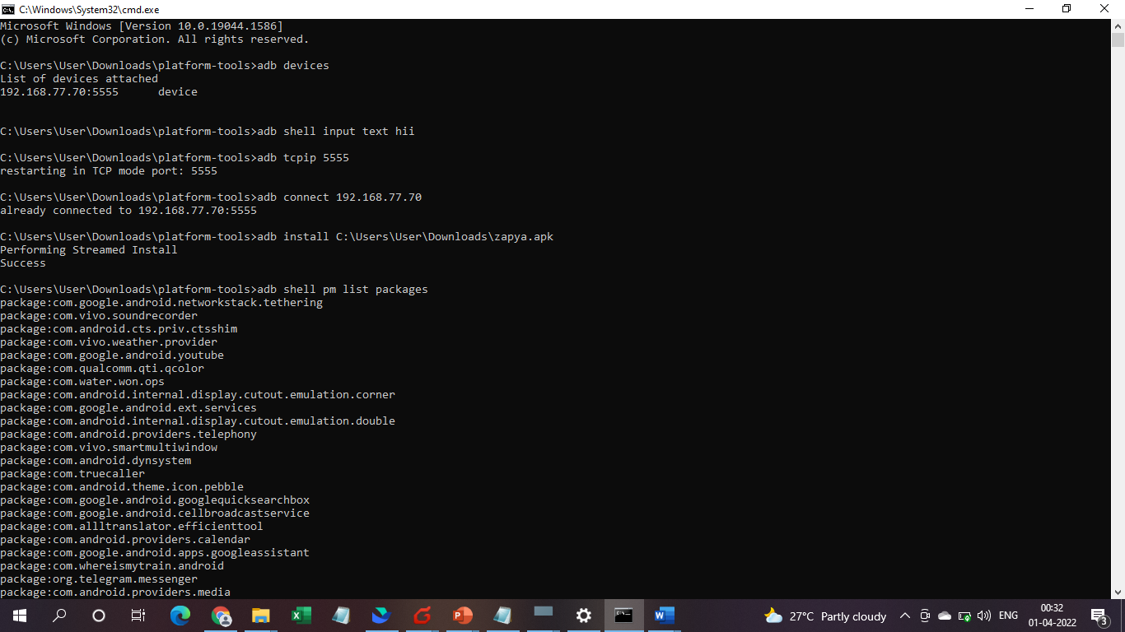

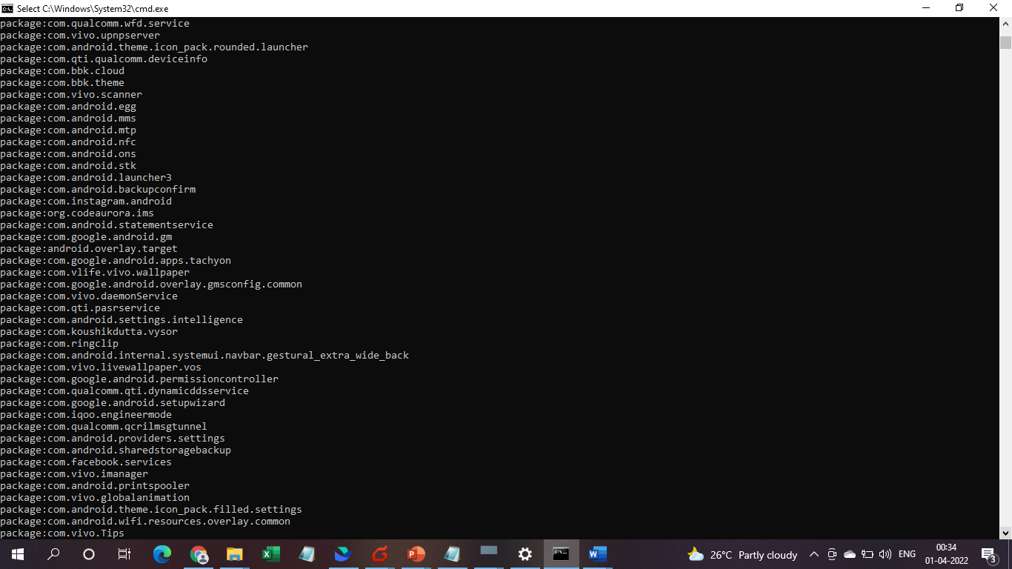

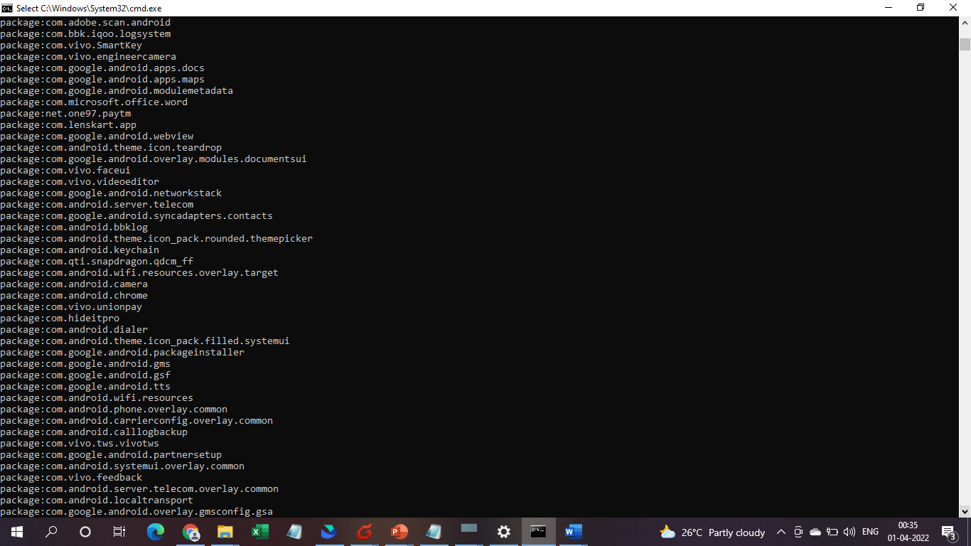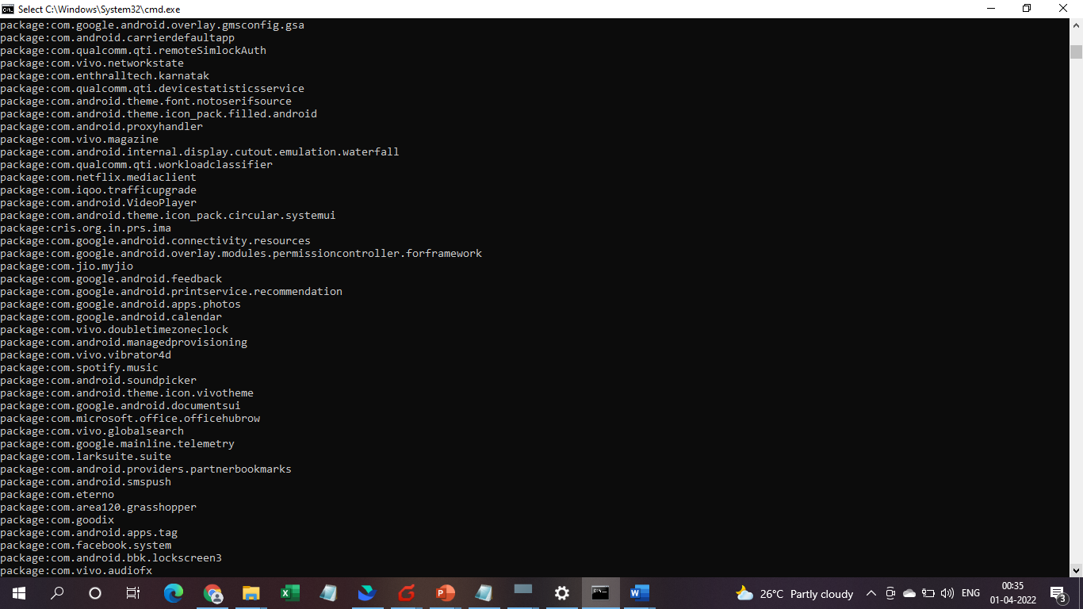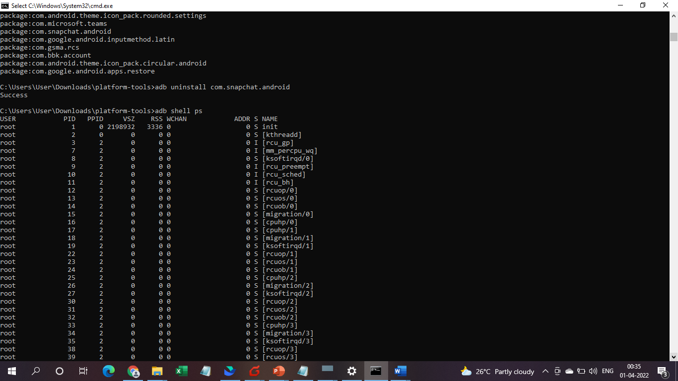

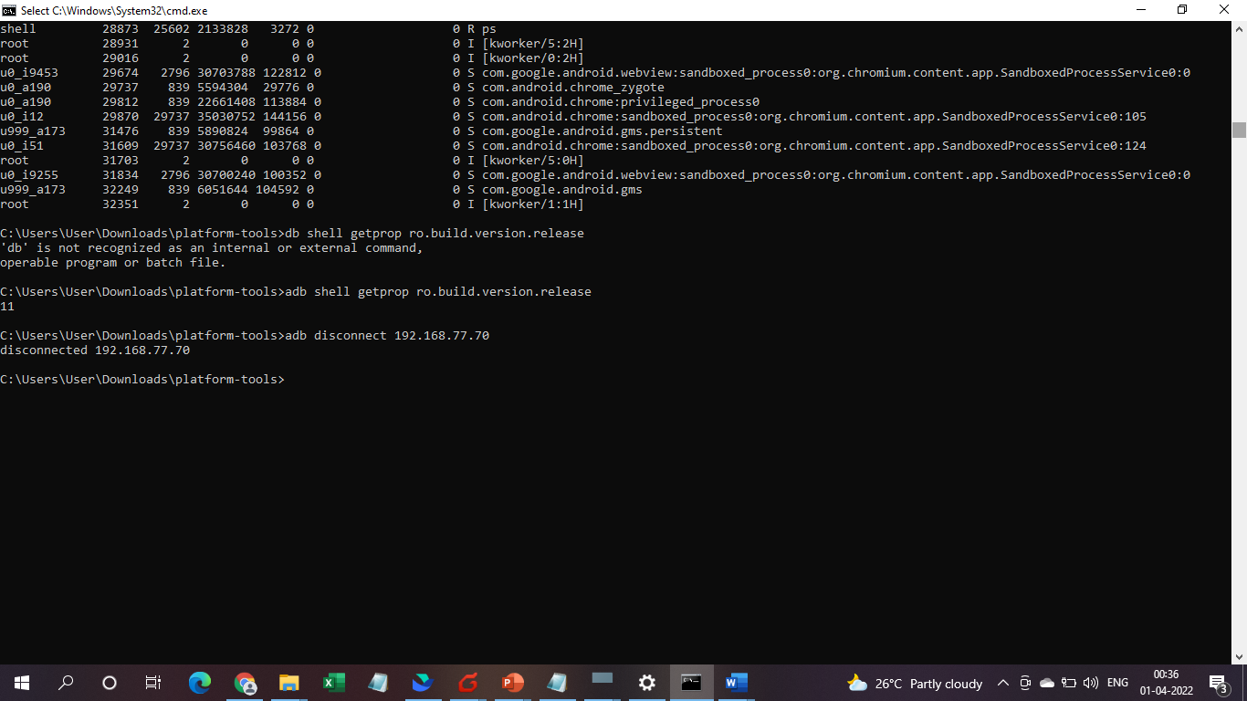

**1. to give the input text in the android**

**adb shell input text "\hello"**

**2. To connect the device over wifi**

**adb tcpip 5555**

**adb connect <Ip address>**

**adb disconnect <ip address>**

**3. To Install an application on android**

**adb install (c:\system\app.apk)**

**adb uninstall "package name"**

**4.to find packages in the android**

**adb shell pm list packages | find str <package name>**

**5. to see processes in the android**

**adb shell ps**